St. Patrick’s School

Guitar Ensemble App
User Guide
Made by Advait Contractor and Ryan Lim Jun Long

Application Setup
Prior setup is required to ensure that the application runs smoothly.

Python Installation
To start, please install Python (at least version 3.12.0) from https://www.python.org/downloads/. Once you are done with this step, please ensure that Python is added to PATH successfully so that you can run Python through the command python , python3 or py on the relevant operating system terminal (Powershell, Terminal or Command Prompt). This will differ from system to system.

PIP Installation
This app will also require another one of Python’s features, known as PIP, or the Python Package Manager. To ensure that it has been installed, please run the command python3 -m pip --version . Please cross-check it using the Figures below. The error messages printed may not be the same as Fig 1.1 and Fig 1.2, as it may vary from computer to computer and operating systems.
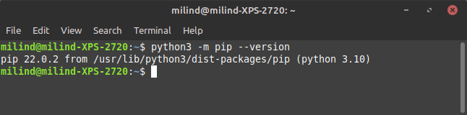
Fig 1.1: Successful Python Package Manager installation

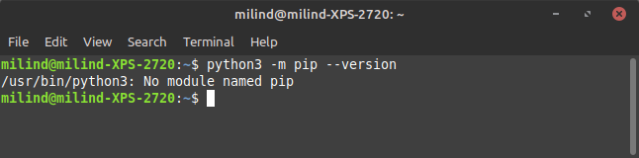
Fig 1.2: Unsuccessful Python Package Manager installation

If the package is not successfully installed, you will not be able to use the application. To rectify this issue, please install PIP using the command python -m ensurepip –upgrade or by appending -m ensurepip –upgrade to the back of the command that launches Python on your computer.

Installing Dependencies of the Application
To install the required dependencies for the application to run, open the URL https://github.com/contyadvait/QuarterMasterLoanSystemUpdated on your computer. Once you have opened this page, please press the code button on the top right of the of the website (as shown in Fig. 1.3) and press the “Download ZIP” button on the dropdown (Fig. 1.4)
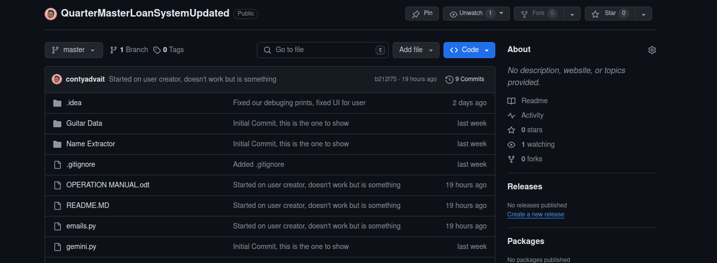
Fig 1.3: The code button on the website

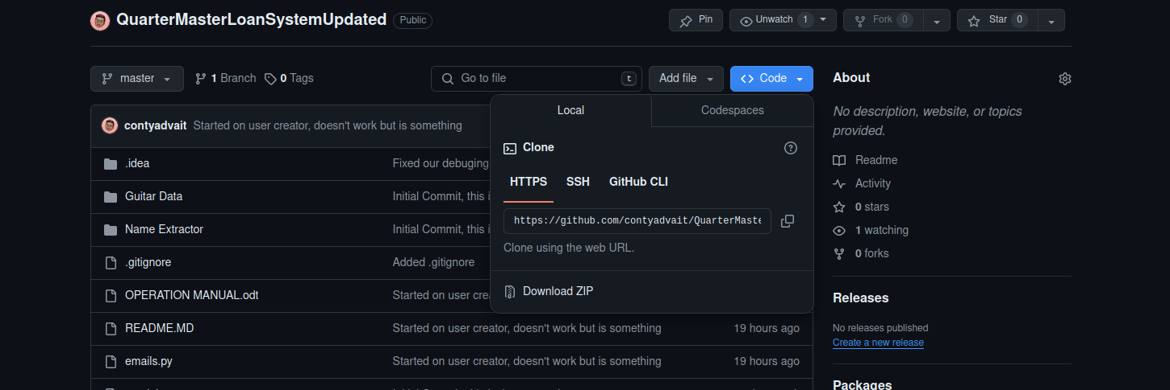
Fig 1.4: The “Download ZIP” button on the code button dropdown

Once you are done, please open your File Explorer, Finder, or your file manager as per your operating system and extract the ZIP file into a folder into a location on your computer that you can easily access. Once you are done, please open the Terminal (Powershell, Command Prompt, or Terminal) and type in cd . Once done typing, switch back to your file manager window with the folder open (Fig 1.5). Drag that into the terminal and press the “Enter” or “return” key on your keyboard.
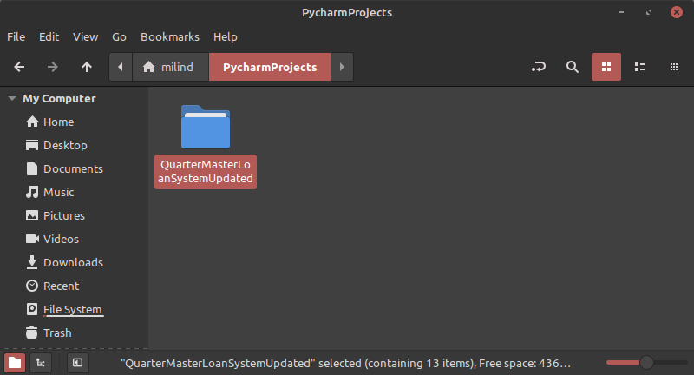
Fig 1.5: A photo of the folder being selected. This folder is to be dragged into the terminal

Once this step has been done, you may move on to installing the required packages.

Installing the packages
To install the relevant packages, type in the command that runs Python on your computer, and add -m pip install -r requirements.txt .

